INTRODUCTION TO EXPERIMENTAL DESIGN
ANSWER PAGE

Himesh Buch
hnb17 (190000724)
5/7/2020

1. - (a) Define the null and alternative hypotheses

H₀: = 0 H₁: (not equal to) 0

(b) What is your conclusion based on the ANOVA Table? (Please circle your answer)

Keep H₀ Reject H₀

(c) Estimates of the components of variance are:

MS_{E} = 0.00438

(MS_{batches} – MS_{E}) / n = (0.02424 – 0.00438) / 5 = 0.003972 (here df = 4, df = n-1 => n = 5)

(d) Find a 95% CI for the intraclass correlation coefficient, assuming L = 0.1154 and U = 9.2780.
What is your conclusion?

Ans:
95% CI = [L/(1+L), U/(1+U)]
= [0.1154/1.1154, 9.2780/]
= [0.1034, 0.9027]
= [10.34%, 90.27%]

(e) Are each of the five calcium determinations in each batch a replication or a repetition?
(Please circle your answer)

They are independent replications.
They are repetitions (also called sub-sampling).

2. - (a) How many blocks are created? _____8____

(b) Which generalized interactions are created? ADE, BDF, ABEF, CDEF

Ans:

ABCD * BCE = ADE
ABCD * ACF = BDF
BCE * ACF = ABEF
ABCD * BCE * ACE = CDEF

(c) Write the 3 equations module 2 that can be used to find the treatment combinations for each
of the blocks:
L₁ = x₁ + x₂ + x₃ + x₄ mod 2

L₂ = x₁ + x₃ + x₅ mod 2

L₃ = x₁ + x₃ + x₆ mod 2

(d) Verify that the treatment combination acdf belongs to the block defined by L1 = L2 = L3 = 1.
Ans:

Since, L₁ = L₂ = L₃ = 1, we get, x₁ = x₃ = x₄ = x₆ = 1 and x₂ = x₅ = 0

L₁ = x₁ + x₂ + x₃ + x₄ = 1 + 0 + 1 + 1 = 3 = 1
L₂ = x₁ + x₃ + x₅ = 0 + 1 + 0 = 1
L₃ = x₁ + x₃ + x₆ = 1 + 1 + 1 = 3 = 1

Given those results, we can say that acdf belongs to the block

3. - 1) I = ABCG=BDFG=ACDF 2) I =ABCG=ADFG=BCDF 3) I =ABCFG=ABCEF=GE

- Complete the above defining relations by including the generalized interactions

Ans:
- (ABCG)(BDFG) = ACDF
- (ABCG)(ADFG) = BCDF
- (ABCFG)(ABCEF) = GE

(b) Are all these designs resolution IV? (Please circle your answer) YES NO

(c) Circle the design you would not recommend.

Ans: I = ABCFG = ABCEF = GE

I = ABCFG = ABCEF = GE is the design I would not recommend

(d) Why you would not recommend this design?

Ans:
Compared to design 1 and 2, design 3 will have less interactions. It is also not good to alias main effect.

4. - (a) how many blocks will be generated? ____ 9________

(b) What is the size of each block? _______3_____

(c) Write the corresponding L₁ and L₂ equations: L₁ = x₁ + x₂ + 2x₃ L₂ = x₁ + x₃

(d) If one of the blocks contains the treatment combination 121, find at least one other treatment combination belonging to this block.
_________221 _______________

Ans:
We will have to take, x₁ = 2 x₃ = 1, and x₂ = 2, L₁ = 1+2+2 = 5 and L₂ = 1 + 1 = 2

5. - (a) Find the complete defining relation for this fraction:

Ans:
3⁴⁻² of a 3⁴ is ½ fraction of 3⁴ design.

I = ABC = BC²D = (ABC)(BC²D) = AB²C³D = ACD

(b) Write out the alias structure for A and for C.

Ans:

A =
AI = (A)(ACD) = CD

C = CI = (C)(ACD) = AD

6. – (a) Find the expected value and the variance of the response variable Y.

E(Y) = V(Y) =

- Write the F₀ ratio test for factor B

- Write the F₀ ratio test for factor C

- Write the F₀ ratio test for BC

Ans: All the parts (a), (b), (c) are included in the image attached here

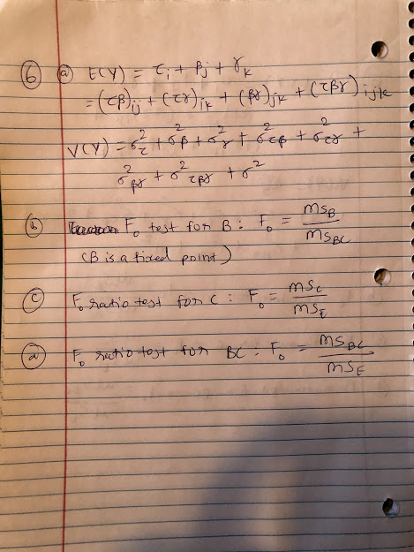

INTRODUCTION TO EXPERIMENTAL DESIGN
01:960:490:01

THIRD EXAM (Virtual Exam) SPRING 2020
Instructions:

1. Name: Himesh Buch & ID Number: hnb17 (190000724)
2. Check your exam: there are 6 problems. This is a personal open-book/open-laptop exam.
3. Use the ANSWER page to collect all your answers; this should be uploaded into CANVAS.

1. - A manufacturer suspects that the batches of raw material furnished by his supplier differ significantly in calcium content. There are many batches currently in the warehouse. Five of these are randomly selected for testing the calcium content. This action makes the factor Batch, a random factor. A chemist makes five determinations on each batch and obtains the following data and ANOVA Table:

Batch 1: 23.46 23.48 23.56 23.39 23.40 ANOVA TABLE
Batch 2: 23.59 23.46 23.42 23.49 23.50 SoV df SS MS F₀ p-value
Batch 3: 23.51 23.64 23.46 23.52 23.49 Batches 4 0.09697 0.02424 5.5342 0.0036
Batch 4: 23.28 23.40 23.37 23.46 23.39 Error 20 0.08760 0.00438
Batch 5: 23.29 23.46 23.37 23.32 23.38 Total 24 0.18457

(a) Define the null and alternative hypotheses

H₀: ___________________ H₁: __________________________

(b) What is your conclusion based on the ANOVA Table? (Please circle your answer)

Keep H₀ Reject H₀

(c) Estimates of the components of variance are:

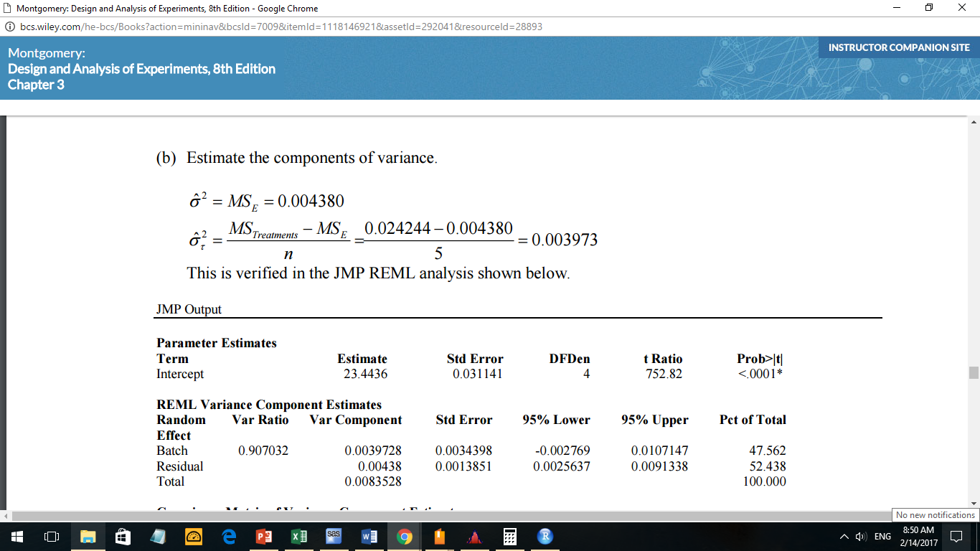

(d) Find a 95% CI for the intraclass correlation coefficient, assuming L = 0.1154 and U = 9.2780.
What is your conclusion?

(e) Are each of the five calcium determinations in each batch a replication or a repetition?
(Please circle your answer)

They are independent replications.
They are repetitions (also called sub-sampling).

2. – In a 2⁶ experiment, with factors A, B, C, D, E, and F, you define 3 interactions to confound with blocks: ABCD, BCE, and ACF.

(a) How many blocks are created? _________________________

(b) Which generalized interactions are created? ___________________
(c) Write the 3 equations module 2 that can be used to find the treatment combinations for each
of the blocks:
L₁ =

L₂ =

L₃ =

(d) Verify that the treatment combination acdf belongs to the block defined by L1 = L2 = L3 = 1.

3.- For the 8 factors A, B, C, D, E ,F, G and H suppose you must choose one among three 2^{8 – 2}
fractional designs. These designs correspond to the following three defining relations:

1) I = ABCG = BDFG= 2) I = ABCG = ADFG= 3) I = ABCFG = ABCEF=

(a) Complete the above defining relations by including the generalized interactions

(b) Are all these designs resolution IV? (Please circle your answer) YES NO

(c) Circle the design you would not recommend.

(d) Why you would not recommend this design?

4. - Suppose you need to confound a 3³ design into blocks using the splits A¹B¹C² and A¹C¹.

(a) How many blocks will be generated? ____________

(b) What is the size of each block? ____________

(c) Write the corresponding L₁ and L₂ equations: L₁ = L₂ =

(d) If one of the blocks contains the treatment combination 121, find at least one other treatment combination belonging to this block.
________________________

5. - For the fraction 3⁴⁻² of a 3⁴ design, defined by I = A¹B¹C¹ and I = B¹C²D¹.

(a) Find the complete defining relation for this fraction:

I =

(b) Write out the alias structure for A and for C.

6. – The following skeleton table shows the Expected Mean Squares for 2 fixed factors, A and B, and a third factor C that is random. This is a mixed model.

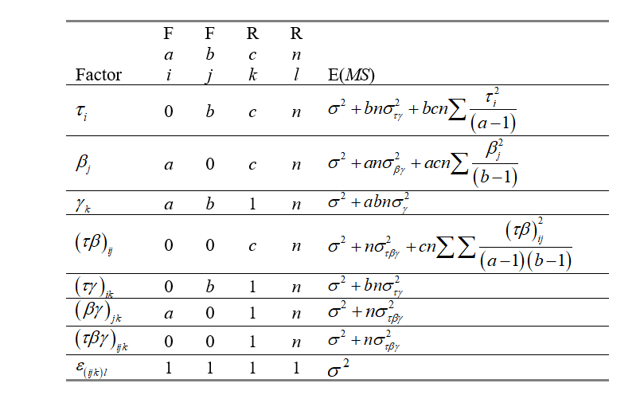

- Find the expected value and the variance of the response variable Y.

E(Y) = V(Y) =

- Write the F₀ ratio test for factor B

- Write the F₀ ratio test for factor C

- Write the F₀ ratio test for BC

